1. **Show initial UML Class diagrams for your requirements**

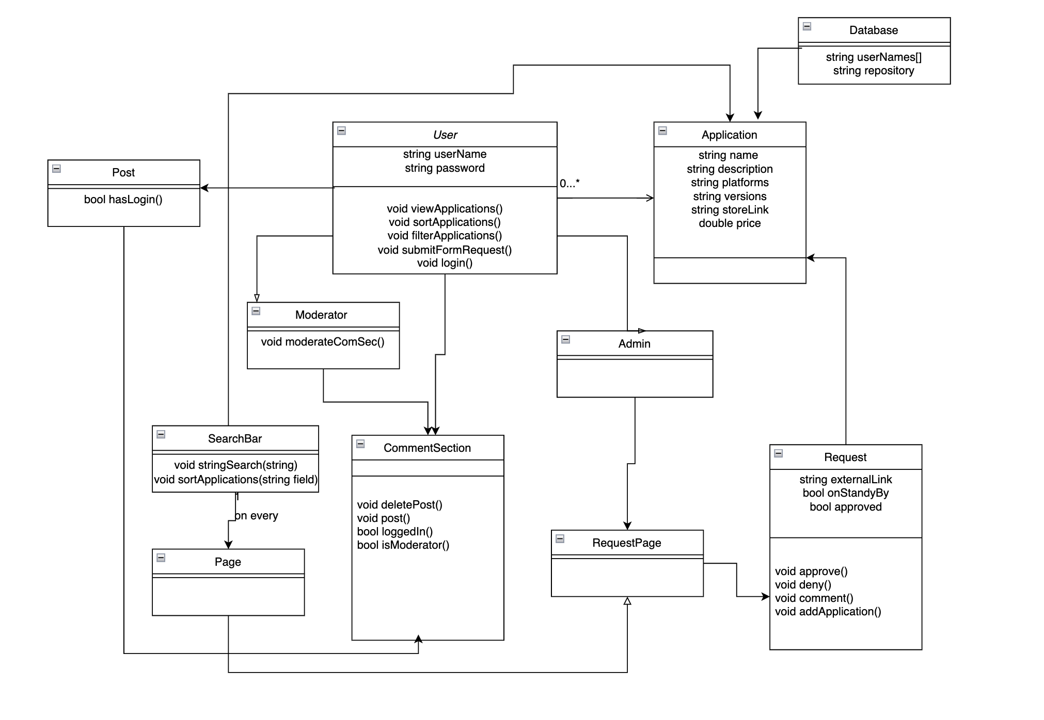

1. **State Diagram**

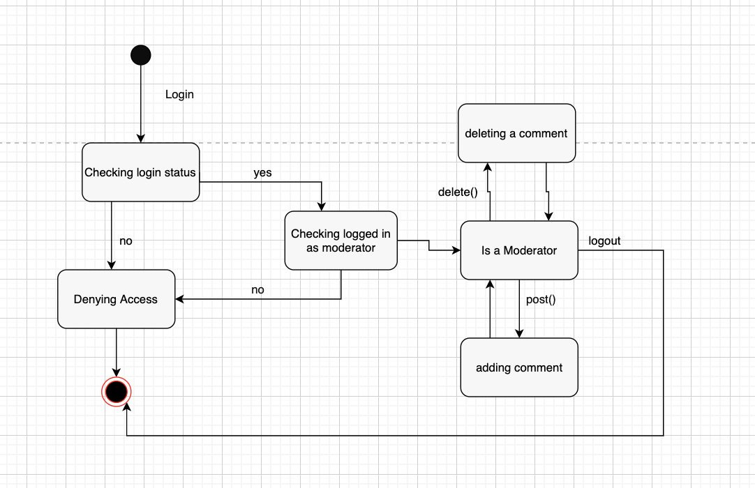

1. **a. UML Use Case Diagram**

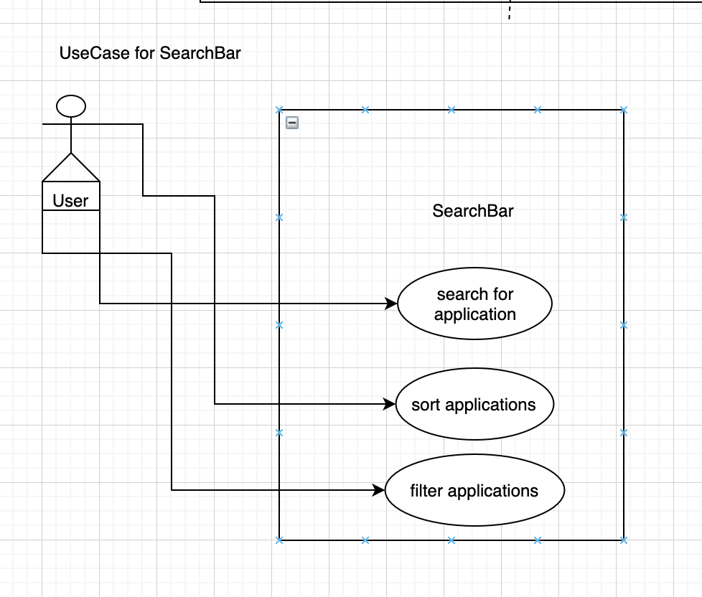

**b. UML Sequence Diagram for Use Case**

